[Your logo]  SEO PROPOSAL  SEO proposal  for [Client name] | 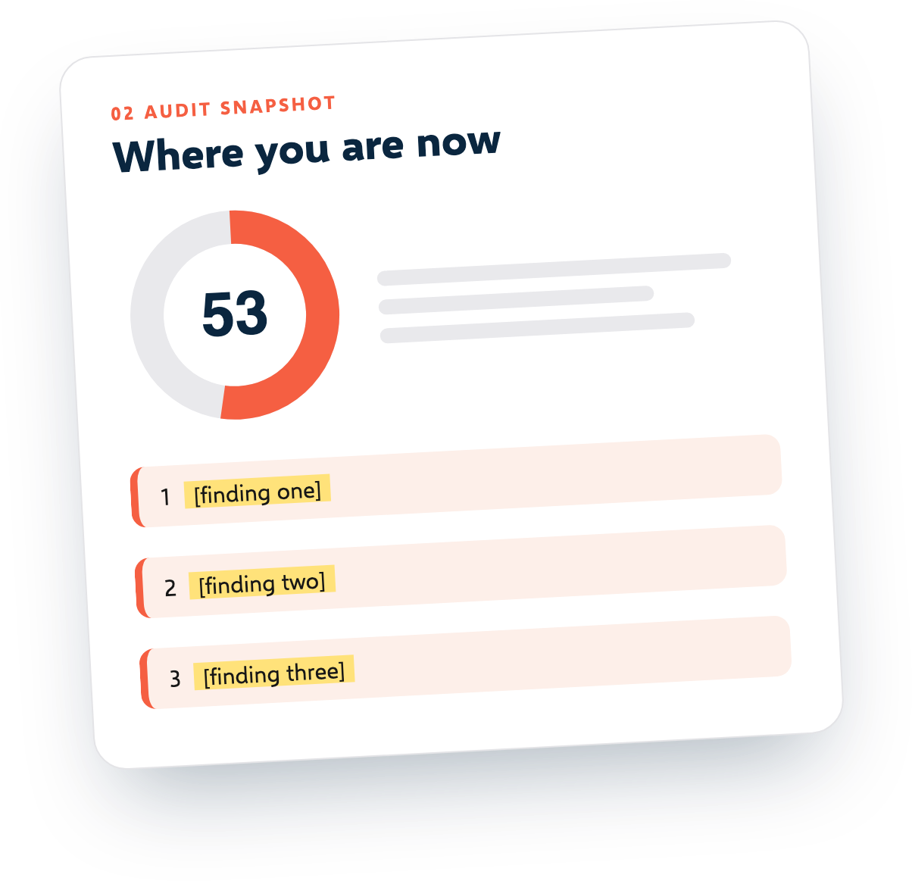

PREPARED FOR  [Client name] | PREPARED BY  [Your name or agency]
DATE  [Date] | VALID UNTIL  [Date, usually 30 days]

HOW TO USE THIS TEMPLATE Replace every yellow [bracket] with your own words, delete the orange tips, and save a copy for each client. Free from SEOSage (seosage.co). You can edit and reuse it without credit.

01 Summary
HOW TO FILL THIS IN Write this last. Three sentences: the goal, what you found, what you propose and the price.

[Client name] wants [the goal in the client's words, such as more enquiries from Google]. Today, [one line from the audit, such as "14 pages are hidden from Google by mistake"]. We propose [what you will do] over [number] months so that [the result the client cares about]. The investment is [price] a month.
02 Where you are now: audit snapshot
HOW TO FILL THIS IN Crawl the site first. Pick three findings a business owner will understand. Appendix B turns technical names into plain words.

We crawled [web address] on [date]. This is what we found.
[score]  health score, out of 100 | [pages]  pages checked | [errors]  kinds of error | [warnings]  kinds of warning

1 | [Finding one, and why it matters to the business]
2 | [Finding two, and why it matters]
3 | [Finding three, and why it matters]

The full audit is attached: [file name or link].
03 Goals and how we will measure them
HOW TO FILL THIS IN Two or three goals, with numbers the client can check. Take the baseline in week one.

We agree what success means before we start.
Goal | How we measure it | Today | Target by month [6]
[Goal 1] | [Measure, such as clicks from Google in Search Console] | [Number] | [Number]
[Goal 2] | [Measure] | [Number] | [Number]
[Goal 3] | [Measure] | [Number] | [Number]

04 What we will do
HOW TO FILL THIS IN Three phases, so the client sees progress early. Say what they receive in each.

The work is in three phases.
Phase | Work | What you receive
Month 1: fix the basics | [Fix the errors from the audit: broken pages, hidden pages, titles, redirects] | [A fixed-issues list and a new crawl to prove it]
Months 2 to 3: improve key pages | [Rewrite titles and copy on the [number] pages that matter most] | [Updated pages and a before and after report]
Month 4 onward: grow | [New pages, internal links, fixes for new problems] | [A monthly progress report]

05 What we need from you
HOW TO FILL THIS IN Name one person who can approve changes, and list the access you need.

[Access to Google Search Console, analytics and the website]. [One person who can approve changes within [3] working days]. [Developer time, if a fix needs one].
06 What is not included
HOW TO FILL THIS IN Be honest here. Clients trust you more for saying that no one can promise a ranking.

[List what is out of scope, such as paid ads, buying links, or writing more than [number] new articles.] No one can promise a ranking. We promise the work and honest reporting.
07 Timeline
HOW TO FILL THIS IN A start date and a month-by-month plan. Do not overstate how fast SEO moves.

[Start date: date]. Expect the first visible changes in [number] weeks, and steady growth over [number] months.
When | What happens
Week 1 | [Kickoff call and access]
Weeks 2 to 4 | [Phase 1 fixes]
Months 2 to 3 | [Phase 2 work]
Every month | [Report and call]

08 Reporting
HOW TO FILL THIS IN Say what arrives each month and when.

Each month you receive [a branded SEO report: the score, what was fixed, what changed and what comes next] and [a 30 minute call]. We crawl the site again every month and compare it with the last crawl.
09 Investment
HOW TO FILL THIS IN Put the price next to the work it covers. State the currency and whether tax is included.

All prices are in [currency]. [Say whether tax is included.]
Item | Price
One-off audit and setup | [Price]
Monthly SEO retainer | [Price] a month
Optional extras | [Price]

Billing: [monthly in advance]. Minimum term: [3 months]. Cancel with [30 days] notice.
10 About us
HOW TO FILL THIS IN Two or three lines, and one real result with a number and a date. No adjectives.

[Two or three lines on who you are, and one result with a real number and a date.]
11 Next steps
HOW TO FILL THIS IN One clear next step is easier to say yes to than a menu.

1. Reply to accept this proposal.
2. Sign below.
3. We book the kickoff within [5] working days.
Client | Date: ______________ | For [your company] | Date: ______________

12 Appendix A: cover email and follow-ups
The cover email
Subject: Your SEO proposal for [business], with what I found on your site
Hi [name],
Thanks for the call on [day]. Before writing this I ran a check of [website]. The short version: [one finding with a number].
The attached proposal shows the three things I would fix first, what it costs and how I would report progress. It is valid until [date].
Could we take 20 minutes on [two options] to go through it?
[Your name]
Follow-up after three days
Subject: One more thing from [website]'s audit
Hi [name], one more detail from the audit that is not in the proposal: [a finding, in one sentence, with what it costs them]. Happy to explain on a call. Do you have any questions about the proposal?
Follow-up after a week
Subject: Closing the loop
Hi [name], I will hold the proposal until [date]. If the timing is not right, tell me and I will check back in [month]. Either way, the audit is yours to keep.
13 Appendix B: say it in plain words
Turn each technical finding into what the client would notice or lose, then add a number.
What the audit says | What the client hears | Why it costs them
Noindex tag present | This page is marked to stay out of Google. | It cannot bring visits, however good it is.
Soft 404 | The page says it does not exist, but the site treats it as live. | Visitors hit a dead end and Google wastes time on it.
Redirect chain | Visitors take two detours to arrive. | Slower pages and lost link value.
Orphan page | No other page links to it. | Visitors and Google can hardly find it.
Multiple title tags | The page has two titles, so Google may pick the wrong one. | The wrong words show in search results.
Missing meta description | Google writes its own summary of the page. | A weaker pitch in the search results.
Thin content | There is too little text to answer a search. | Little reason for Google to show the page.
Canonical URL different | Two addresses lead to one page, and we need to say which one counts. | Split credit between copies of the same page.
Slow response time | The server takes too long to answer. | Visitors leave before the page loads.
No structured data | Google cannot show extras such as prices or ratings. | Plainer results than competitors with extras.

